**ADF Git Connections:-**

Git connection can be added using Manage tab=> Git configuration.

Following parameter need to selected and specify root folder.

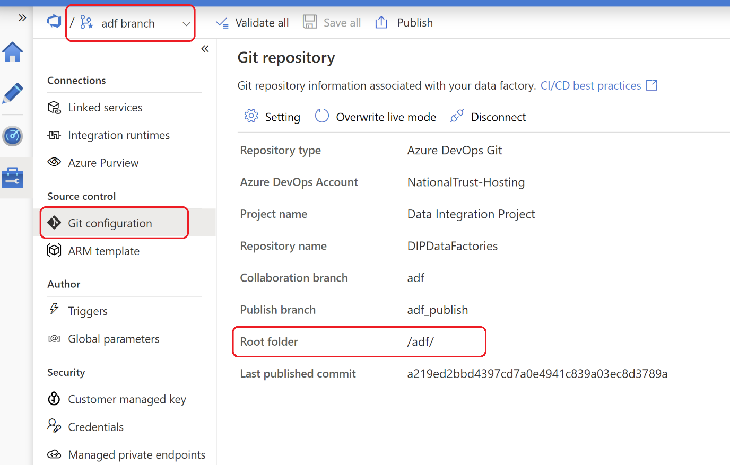

If anything need to change in future then need to disconnect from git and then need to add new connection?

Add new connection screen looks like

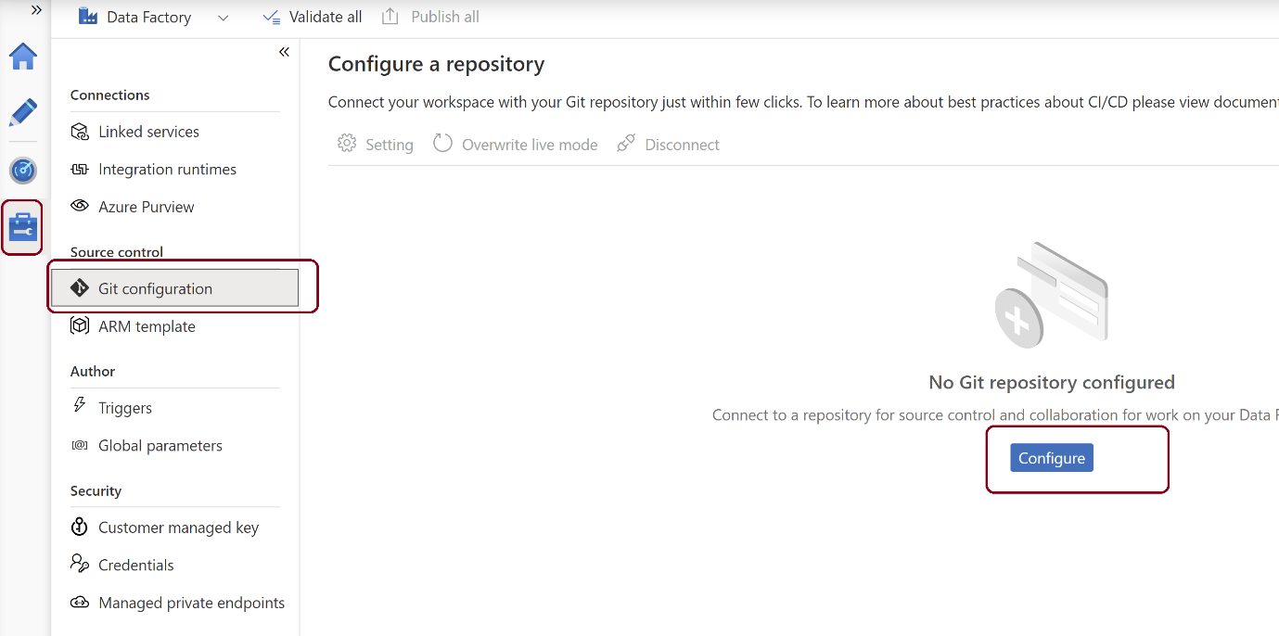

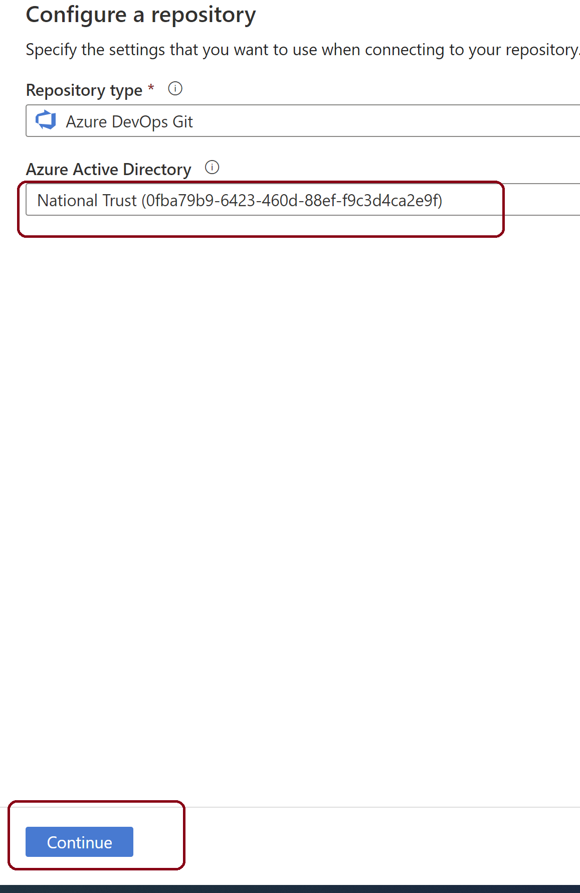

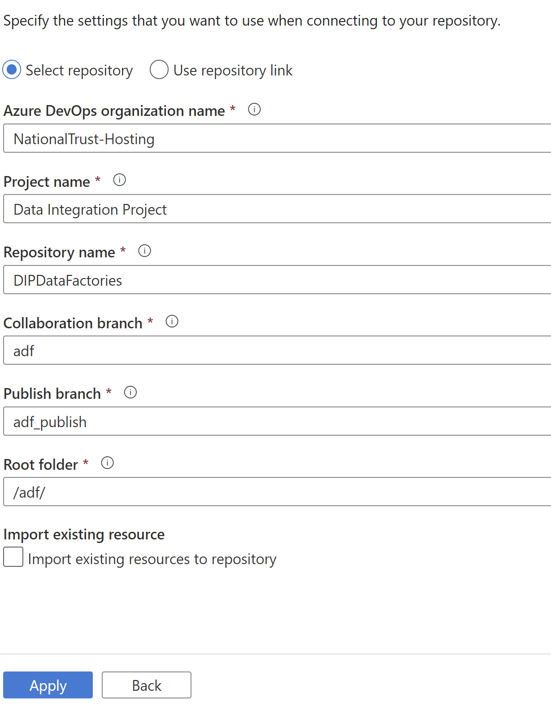

After that check that

1. adf branch has all required code
2. Feature branch also up to date if anyone working on feature branch
3. Publish from adf branch
4. Deploy to DEV